23CSE111 OBJECT ORIENTED PROGRAMMING
S2 B.Tech CSE
Department of Computer Science and Engineering
Amrita School of Computing, Amritapuri Campus
CASE STUDY
PHASE – 2 (Design)
Architectural Modelling (CO2)

Group No : 14
Team Members :
Roll No | Student Name
Ishaan S Vanneri | AM.SC.U4CSE25323
Niharika S H | AM.SC.U4CSE25338
Ganga J | AM.SC.U4CSE25362
Karthikeya S Arun | AM.SC.U4CSE25326
Madhav S Thampy | AM.SC.U4CSE25330

- Problem Title : Attendance Management System

STRUCTURAL DESIGN
- Class diagram
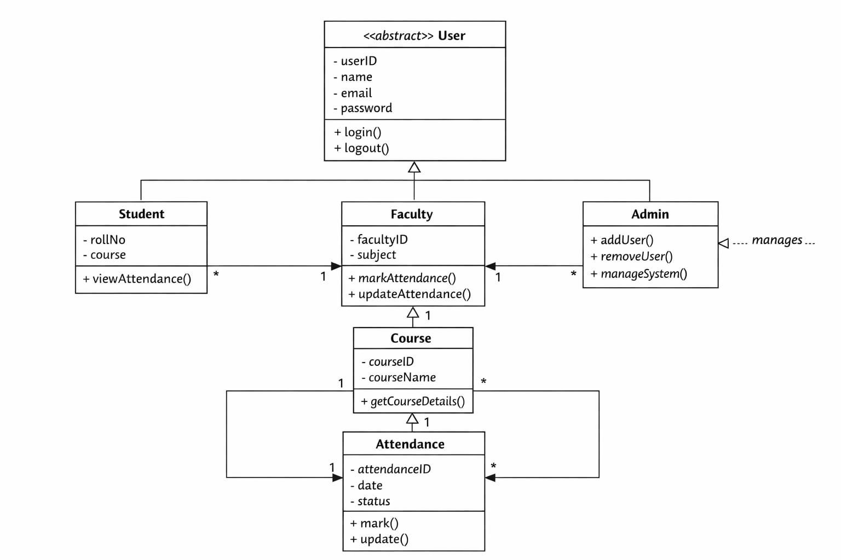

BEHAVIUORAL DESIGN
- Use-case diagram
- List of actors
- Student
- Faculty
- Admin
- List of use-cases
- Login :
Users (both students and faculty) log into the system using credentials.
- View Attendance :
Students can check their attendance records.
- Mark Attendance :
Faculty marks attendance for students
- Update Attendance :
Faculty edits attendance if needed.
- Manage Users :
Admin adds/removes students and faculty.
- Assign Courses :
Admin assigns courses to faculty and students.

- Use case diagram (use UML notations)
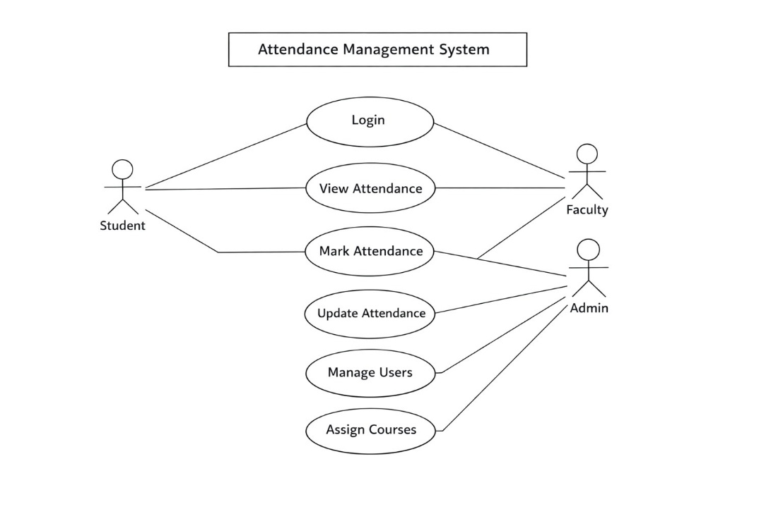

- Sequence diagram (use UML notations)
  - Teacher Records Attendance

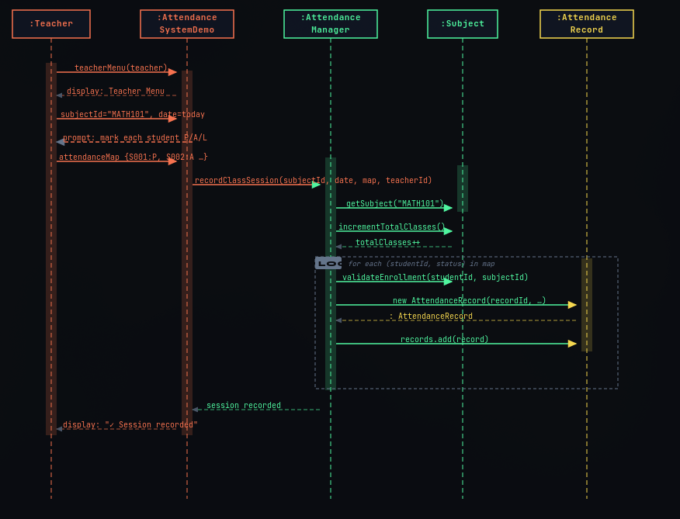

Scenario: The teacher selects a subject (e.g., MATH101) and inputs the attendance status for each enrolled student. The system validates the enrollment and creates new attendance records for the session.

  - Student Login & View Dashboard

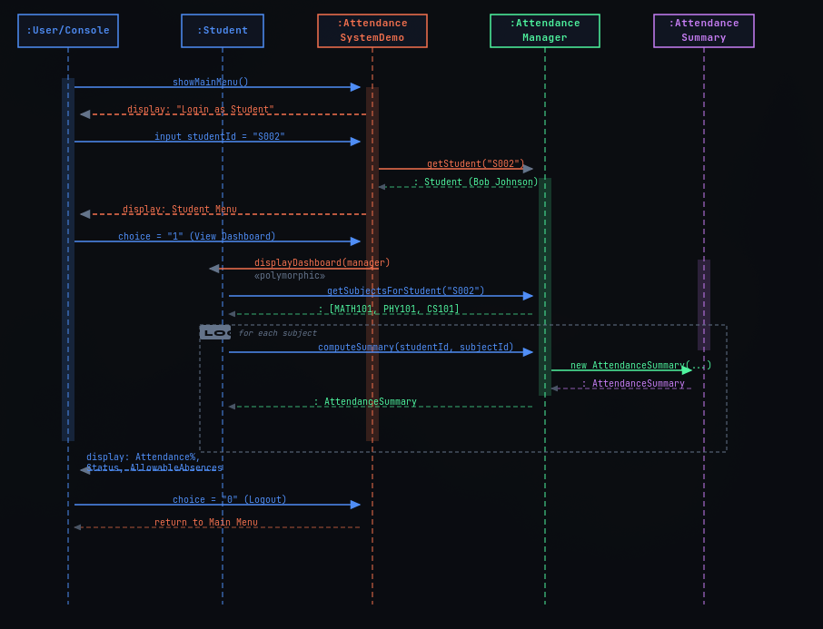

Scenario: A student logs into the console. The system fetches their enrolled subjects and computes an attendance summary for each, displaying their status and allowable absences.

  - Edit Attendance Record

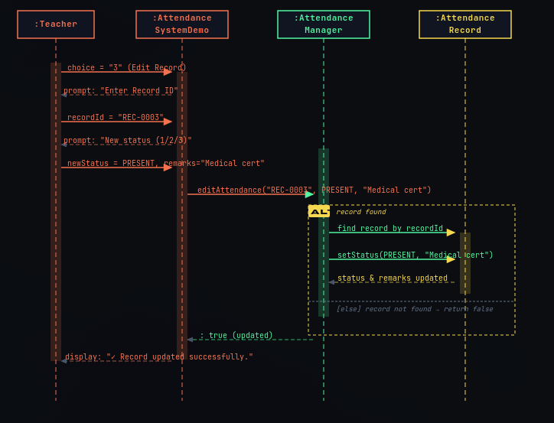

Scenario: A teacher identifies an error in an existing attendance entry. They enter the specific Record ID and provide the updated status (e.g., changing from Absent to Present due to a medical certificate).

- Teacher Dashboard & Alerts

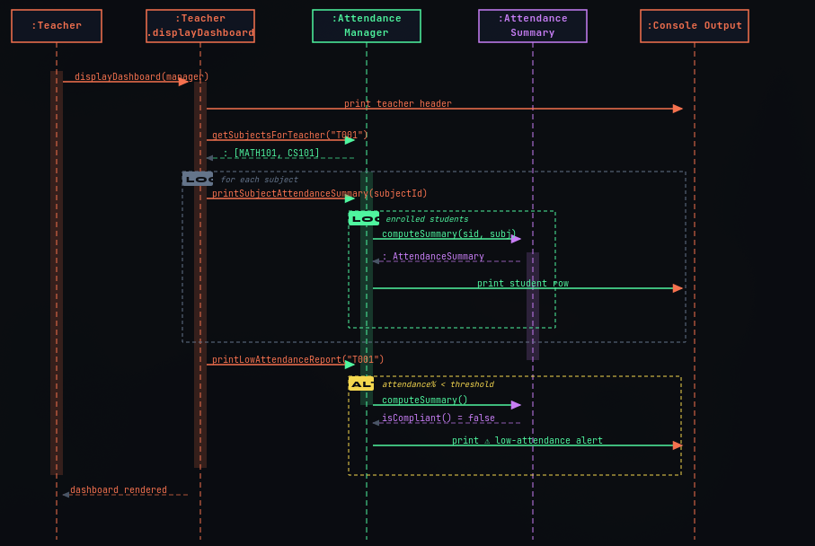

Scenario: The teacher requests a dashboard view. The system iterates through the teacher's subjects, generates summaries for all enrolled students, and prints specific alerts for students whose attendance falls below the required threshold.

